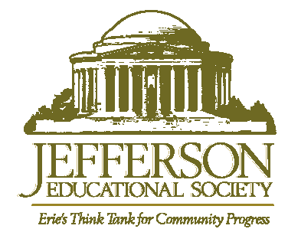
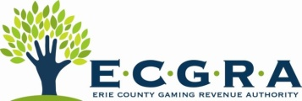
CONTACT: Miriam Lamey
press@epicwebstudios.com
(814) 746 6987

FOR IMMEDIATE RELEASE

#OurErie Short Film Showcases a “Renascent” Erie
Rust Belt Rebound Film Garners National Press via The Atlantic’s James Fallows & APM Marketplace

Erie, Pa. (April 6, 2016) – Erie, PA, professionals united to write, direct, shoot and edit a 4-minute film titled ‘Our Erie’ in response to recent national media coverage. More than 100,000 people nationwide have viewed the short film in just 48 hours, which was released Tuesday, April 4, by executive producers Perry Wood of the Erie County Gaming Revenue Authority, Ferki Ferati of the Jefferson Educational Society, and David Hunter of Epic Web Studios.

“The recent national media focus on Erie, Pennsylvania somehow felt like my home town was taking cannon fire. I refuse to accept the characterization of Erie as a “sinking ship”. Erie, PA is not a perfect place, but we are not broken, either. This film provides an inside look at Erie, and really, the narrative is familiar to many Americans in many cities across the rust belt and beyond.” says David Hunter.

Produced by John C. Lyons of Lyons Den Productions, in association with MenajErie Studio, #OurErie is the collaborative effort of more than two dozen writers, editors, producers, filmmakers, and artists in Erie, Pennsylvania. The film features shots of more than 80 locations in Erie County.

National correspondent for The Atlantic, James Fallows, posted an article Wednesday morning on The Atlantic’s website, calling Erie “the representative American city of this moment.”

“The video as a whole touches on many aspects of a renascent Erie,” Fallows writes. “After the video itself, I encourage you to stay for the credits list, which starts at time 4:20 and shows how many local organizations were involved in creating this project. You don’t get that kind of involvement without the sort of civic fabric that holds communities (or countries) together and allows them to thrive.”

The release of the film was also mentioned on American Public Media’s Marketplace Tuesday evening. The daily radio show has reported recently on Erie as part of its “Big Promise” series.

#OurErie can be viewed:
On the Jefferson Educational Society’s Facebook page: fb.com/JeffersonErie
On the Epic Web Studios YouTube channel: youtube.com/epicwebstudios.

To schedule interviews with members of the #OurErie crew, please contact:

Miriam Lamey,
Executive Coordinator, Epic Web Studios
814-746-6987 | press@epicwebstudios.com

